High Risk Access Attestation Certification Training Guide
ID Central– Access Review

1. Document Purpose

Objective
This document provides guidance to certifier on how to review and certify access assigned to users, account entitlements, and elevated privileges as part of the certification process.
The purpose of the certification is to ensure that access remains appropriate, business justified, and compliant with organizational governance requirements. Certifier can approve, revoke, reassign.

Audience
Audience for the following doc can be HRAA certifier, certifier can be:
- IAM Internal Audit Team
- Manager
- Entitlement Approver
- Backup Approver
- Other designated reviewers

Scope
This guide provides instructions for Internal Audit Teams responsible for scheduling HRAA certifications and Certifiers responsible for reviewing and certify access.
- Certification scheduling
- Certification activation
- Access review
- Certification decisions
- Sign-off process

Definitions
Term | Meaning
Certification | Process of reviewing user access
Certifier | Attester

Pre-requisite
Always ensure application is aggregated and identity refresh task is complete to have data accuracy, before activating a certification.

2. HRAA Certification Overview

What is High Risk Access Attestation ?
HRAA certification allows designated certifiers to review access assigned to users or accounts within their scope of responsibility. Depending on the type, the certifier may be a manager, entitlement owner, entitlement backup approver, or another designated reviewer.
During the certification process, certifier can:
- Approve access that is still required
- Revoke access that is no longer required
- Reassign to another designated certifier

Process Flow

Schedule HRAA Certification
IAM internal Audit team can schedule, configure and define scope of HRAA certification.

Step 1: Login to SailPoint IdentityIQ
- Open the SailPoint IdentityIQ application.
- Enter valid IAM audit credentials.
- Login successfully.

Step 2: Navigate to Certifications
- Navigate to setup > Certifications
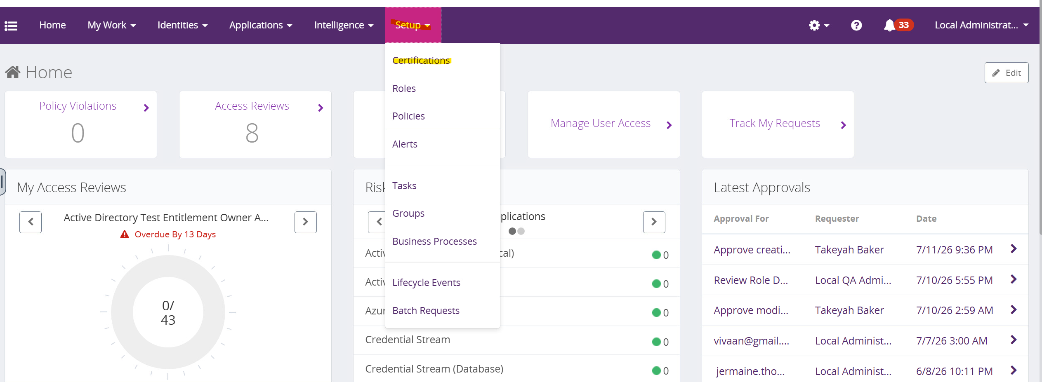
- Select the option to create a new certification, select manager
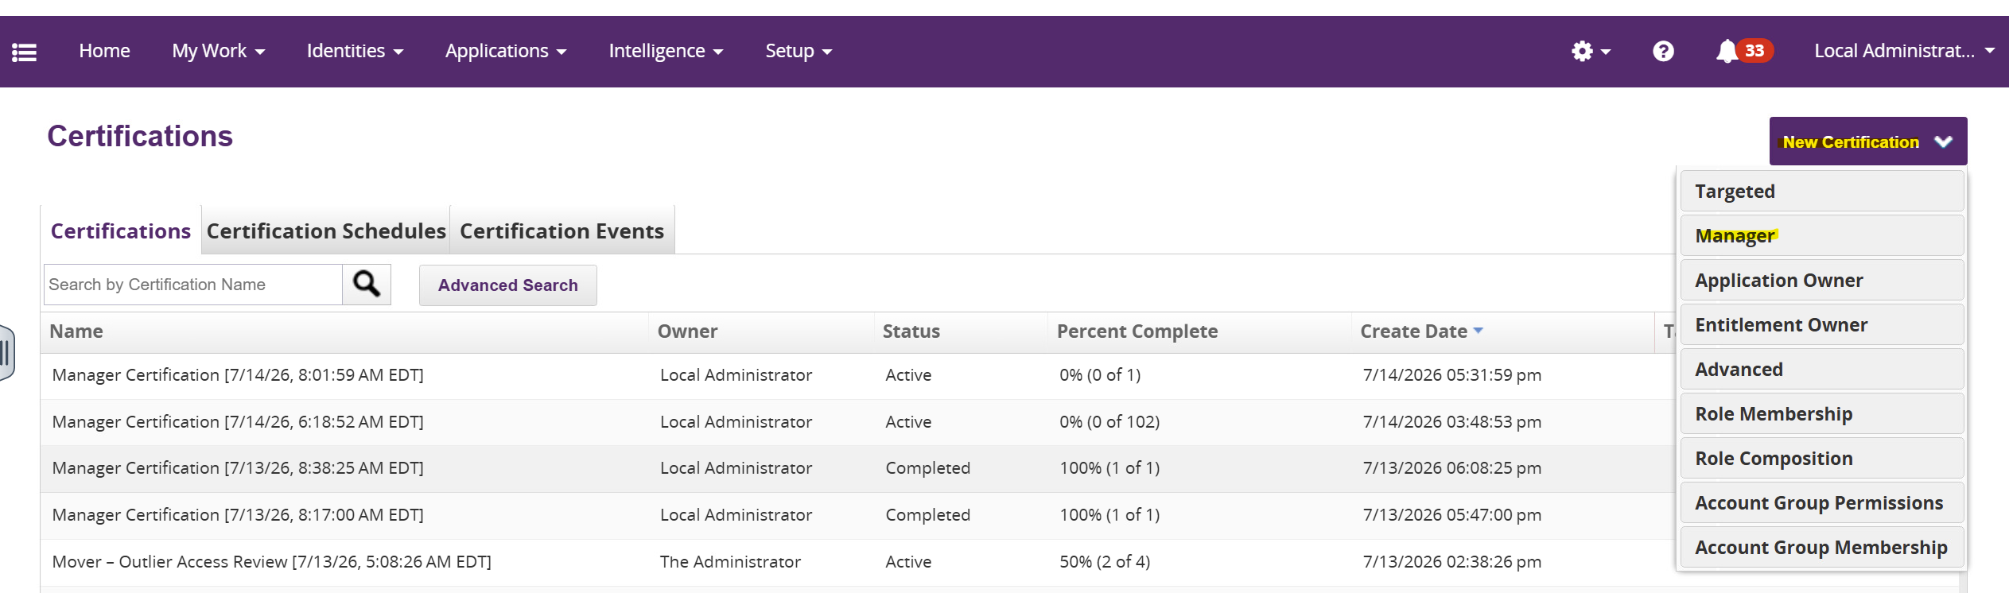

Step 3: Configure Certification
- Provide certification name.
- Select recipients/certifiers. (The selected manager will receive certification items for users reporting to them.), If all managers are selected, all managers configured in system would receive certifications for all reportees under them.
- Select application as Active directory and ensure to remove included roles.

- Configure when the certification should run. (note that certification can be only scheduled for future date)
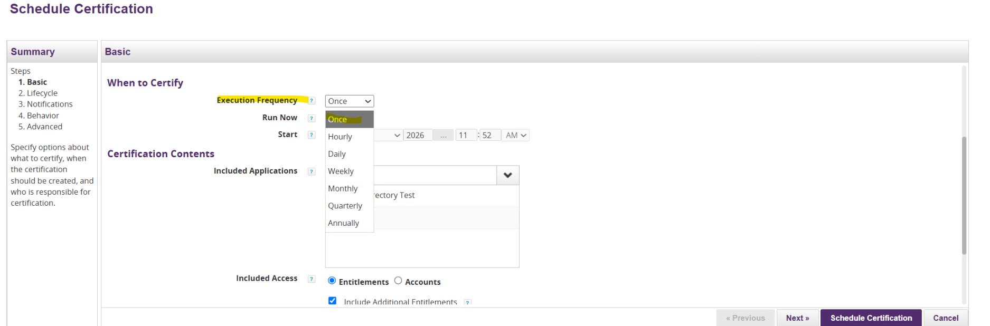
- Execution Frequency:
    - Once
    - Monthly
    - Quarterly
    - Annually
  - Start Date
  - Due Date
OR
- Run now to schedule certification after confirmation
- Click next to configure lifecycle.
- Enable staging period to be able to see preview before confirming and assigning certification to selected certifiers
- Revoke Immediately and automatic closing should be disabled to avoid users losing access even before decision is made by approver.
- Click next
- Setup initial notification to “NH_EmailTemplate_HighRiskAccessAttestation_Initial_Notification” which will give all details for the certifier that they need to know when a certification is created
- Click next
- Set up escalation and reminder timelines and notifications
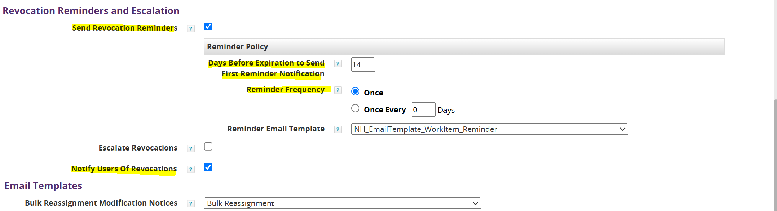
- Enable show elevated access so that the certifier can be aware that they are taking decisions for an elevated access.
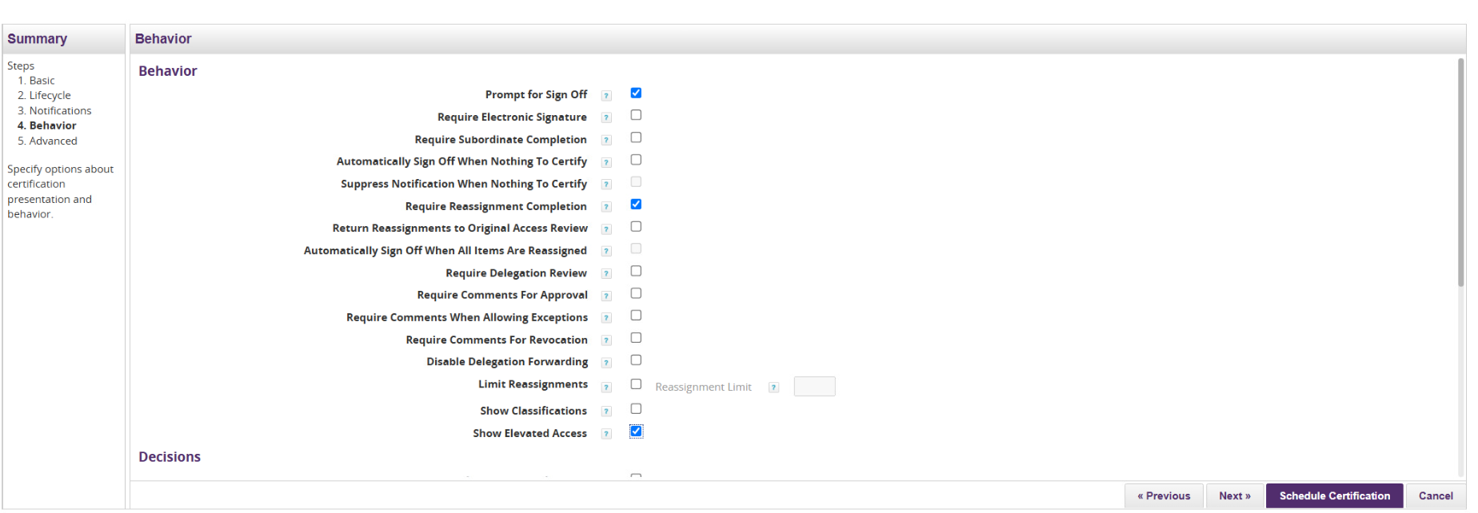

- Click Next
- Certification contents > Generate certification for the specified managers only to run certification on selective or choose for the specified manager and their subordinate managers to run for subordinate managers too
- Click on schedule certification
- Since staging period was enable before confirming and activating the certification preview can be seen
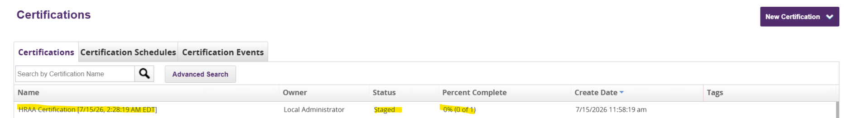
- Click on certification to preview and activate certification or cancel certification
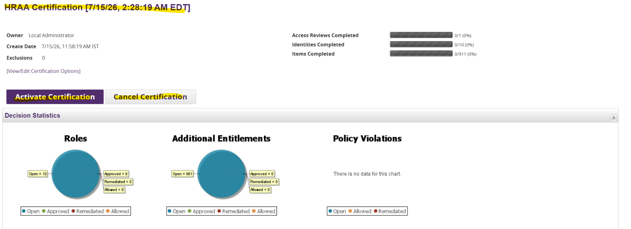
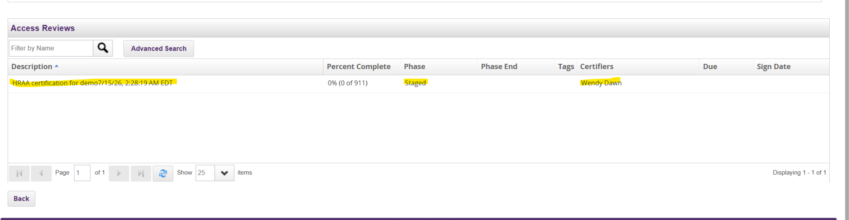
- Click on certification
- Verify certifier details and review items. Since its a preview, requestor will not be able to take action, click on back button to go to staging screen.
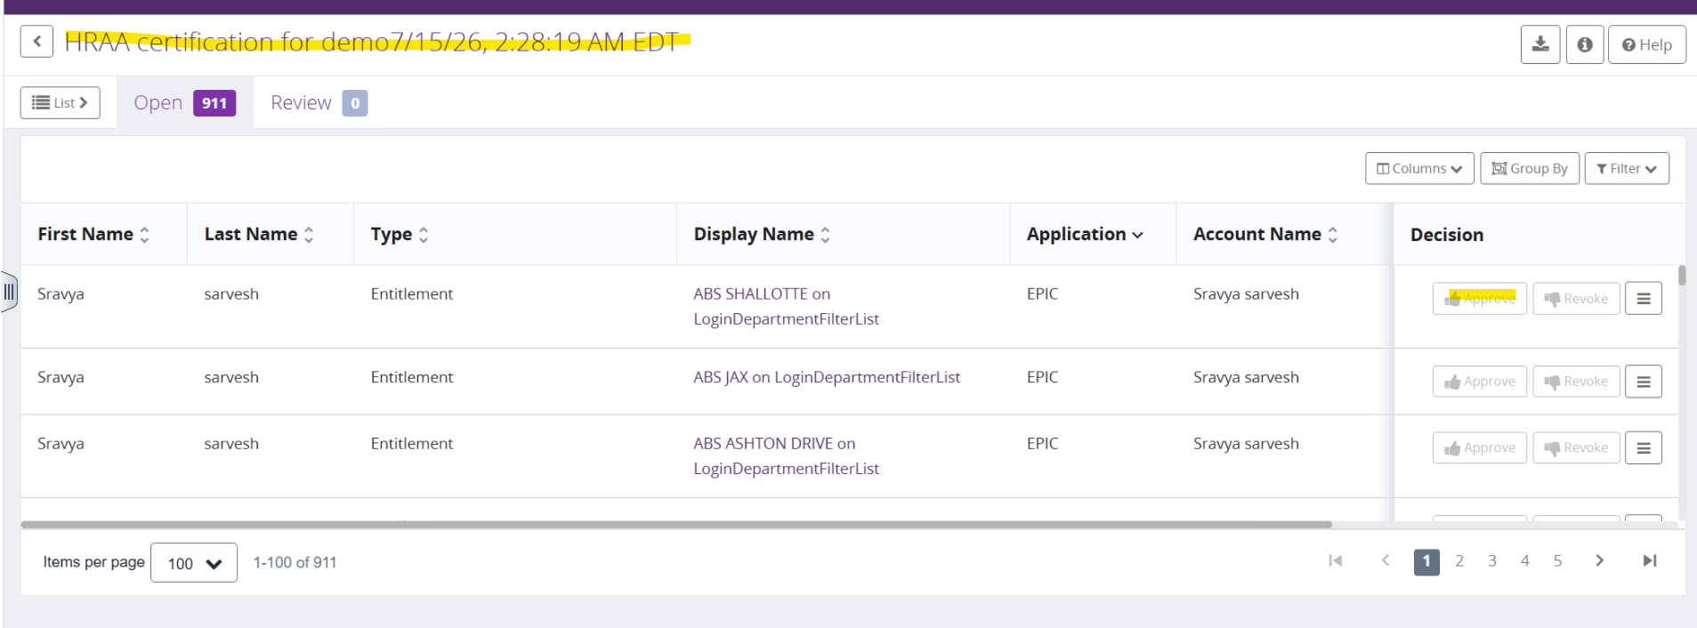
- Click on activate certification.
- Once activated, the certifier is notified via email, and certification status is changed from staged to active.
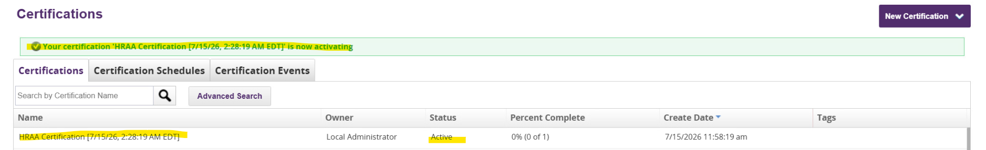

Accessing HRAA Certification

Step 1: Receive Certification Notification
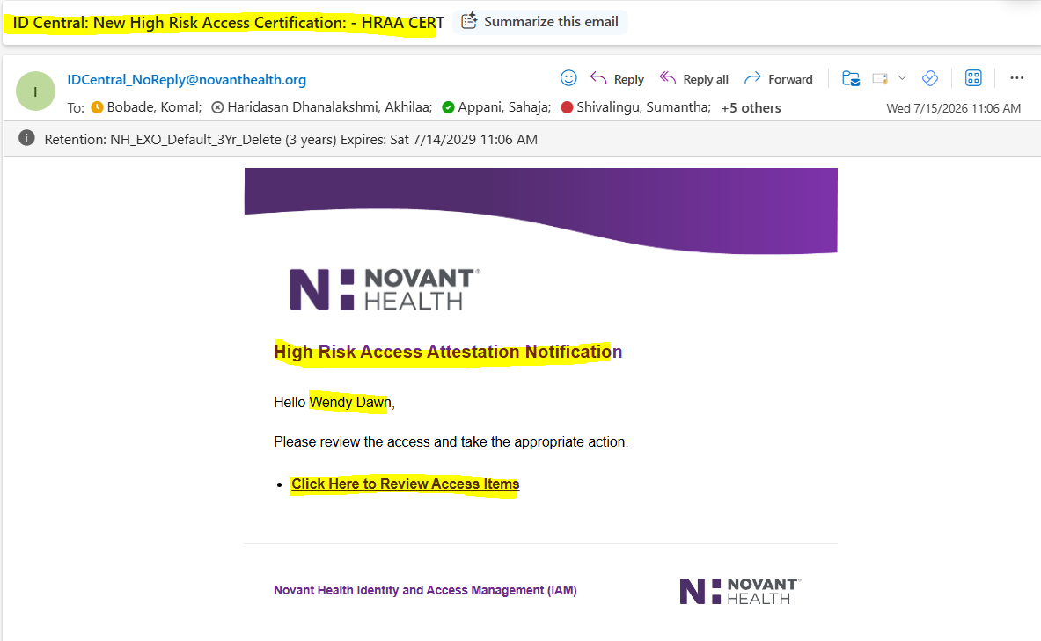
The certifier receives an email notification informing them that a certification review has been assigned.

Step 2: Access Certification
Option 1: Steps
- Open the SailPoint application URL.
- Enter valid credentials.
- Navigate to my work > work items to view assigned work items.
- Select the Certification pending review.
- Open the certification review.
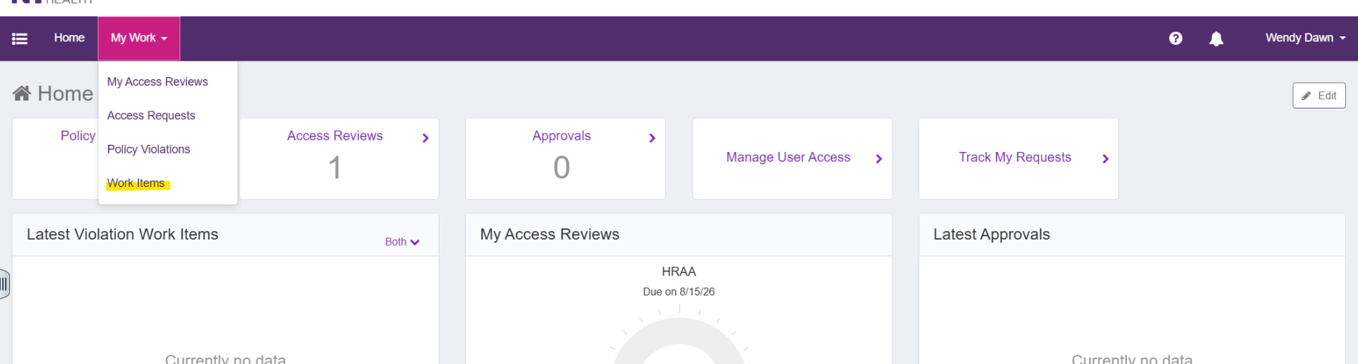
Or
Option 2: Steps
- Login to SailPoint.
- Click Notification (Bell) icon.
- Click on others
- Open assigned certification/Work item.
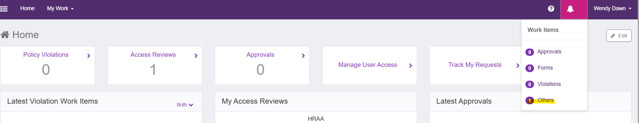
Or
Option 3: Steps
- Open certification notification email.
- Click on certification link.
- Login to SailPoint if not already logged in
- Review assigned certification.

Click on view
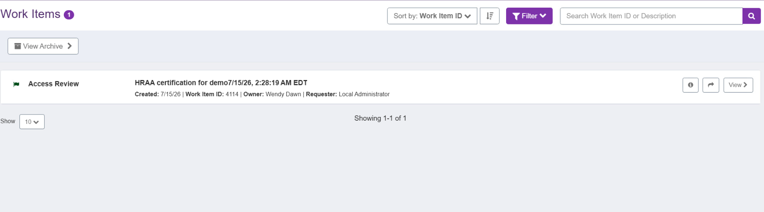

Step 3: Review Access Details
The certifier reviews certification and takes appropriate action against each access.
The manager can perform the following actions:
- Approve Access
- Revoke Access
- Reassign
- Bulk approve
- Bulk Revoke
- Bulk Reassign
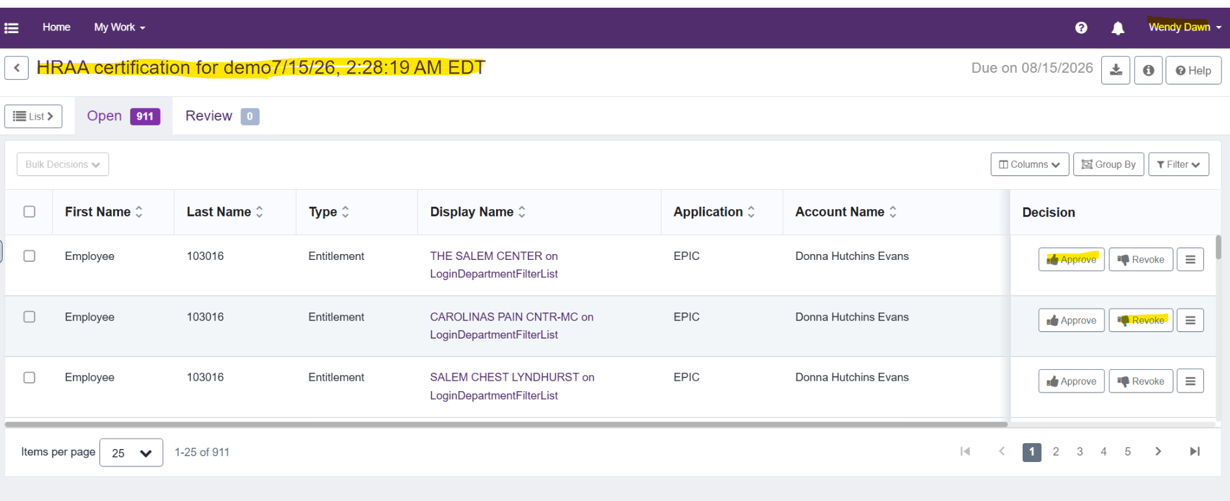

When to Approve:
- Users require access to perform job responsibilities.
- Access is still valid.
Action:
Select Approve and provide comments if required.

When to Revoke:
- Users no longer require access.
- Access is inappropriate or excessive.
Action:
Select Revoke and provide comments if required.

When to Reassign:
- Transfer the certification item to another qualified reviewer when the current certifier is not the appropriate person to make the access decision.
Action:
Select Reassign, select new certifier and provide comments if required.

Bulk Action:

To take bulk action, select header box and chooser select page or select everything and choose appropriate action, certifier can choose
- Approve
- Reject
- Reassign
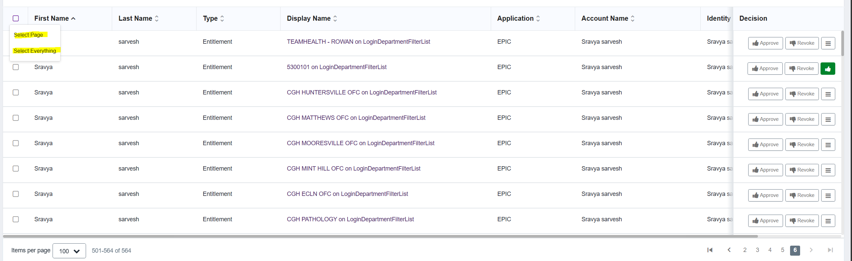
Save decision to draft the reviewed decision, saved decision will be moved to review

Step 4: Submit / Sign-Off Certification
Sign-Off represents the formal completion of the certification review.
- Decisions are not considered finalized until Sign-Off is completed.
- Revocation actions and downstream processing begin only after certification sign-off.
- Unsaved or unsigned certifications remain in a pending state.

Steps:
- Review all assigned access items.
- Ensure that decisions are completed.
- Submit certification.
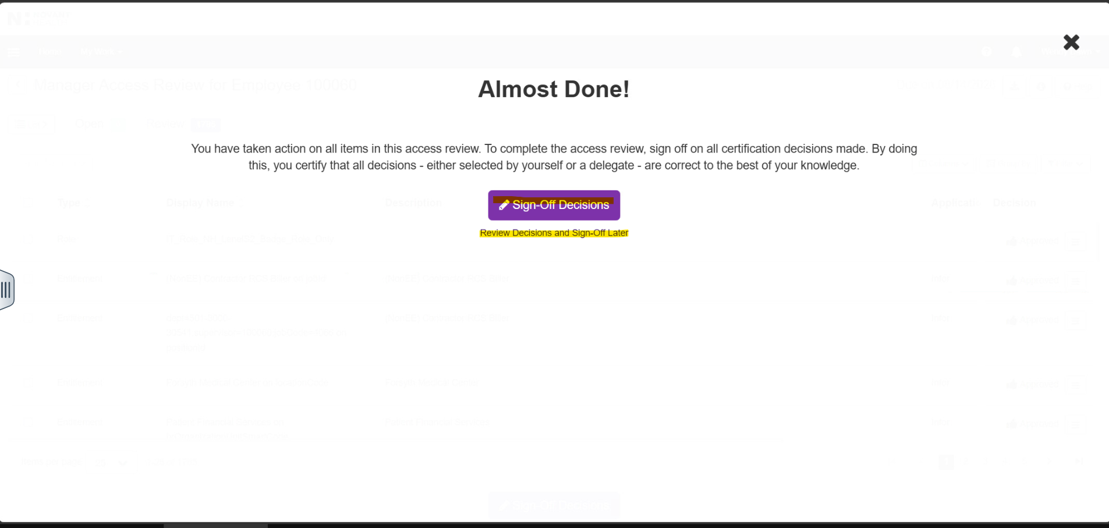
OR
- Review Decisions and sign-off later
- To close the certification, click on sign-off decisions
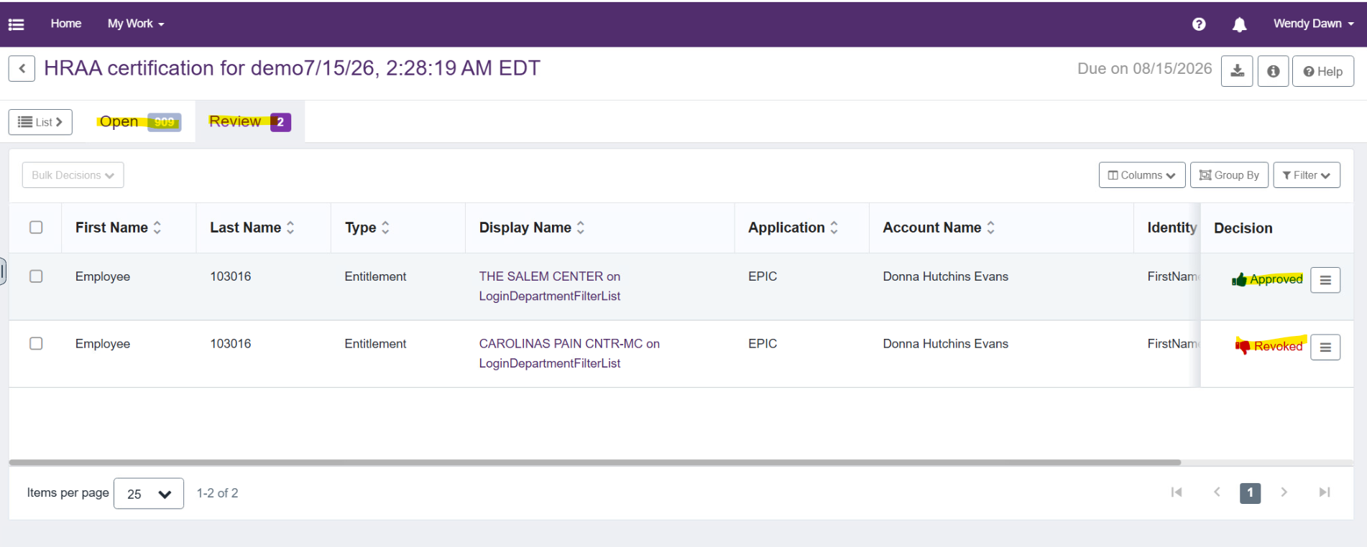
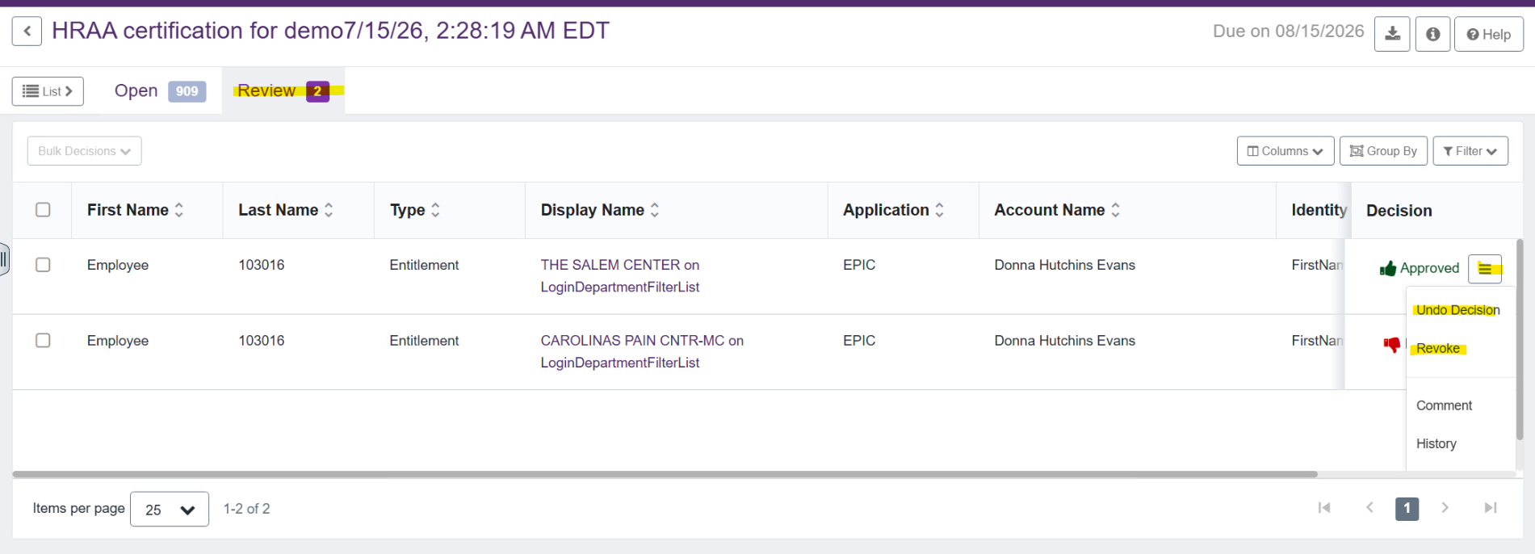
- Once review has been made and decisions are finalized, certifier click on the sign-off decisions button

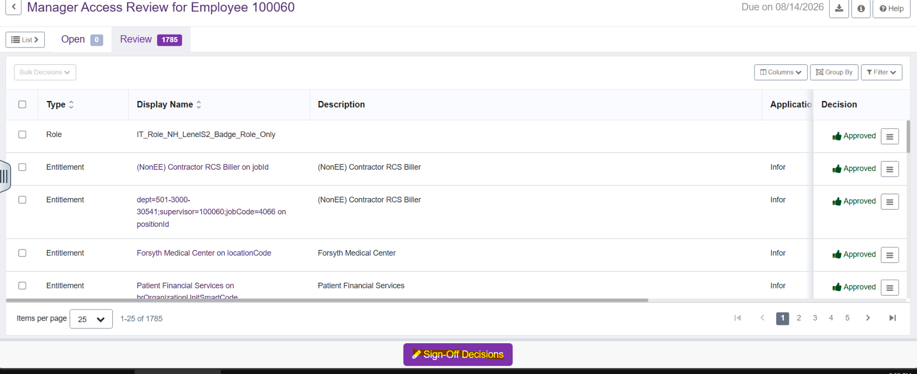

- Certifier decisions are reflected, and appropriate actions on respective access are taken by ID: Central.
- Certification phase changes from active to completed
- Upon revocation of access as per certifier decision, user is notified

